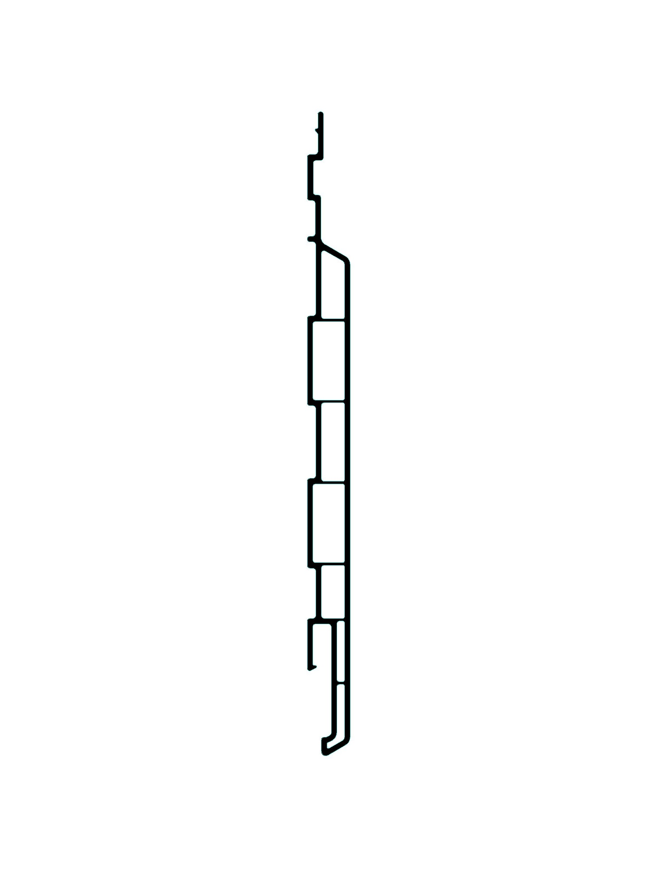


CRITICAL
ATTENTION: REFER TO SET UP LENGTH TOLERANCE PAGE

LASER PRINTED DESCRIPTION:
CHAMCLAD 6” Edmonton AB Miami-Dade County Product Control Approved Date & Time

ChamClad
DIE# 15766
CWS 6” WALL PANEL

